**EXPERIMENT-6**

# Active first order LPF, HPF using OP-AMP.

-----------------------------------------------------------------------------------------------------------------------------------------------------------------------------------------------------------------------------------------------------------------------------------------------------------------------------------------------

1. To Design a Active first order LPF, HPF using OP-AMP.
2. To Verify the functionality of above circuits.
3. **Aim:**
4. **Specification:** circuit uses LM741 IC
5. **Apparatus**

**Hardware:**

1. Resistors (1k $Ω$)
2. Capacitor (0.1uF)
3. DSO
4. LM 741
5. Signal generator
6. Bread board
7. **Theory:**

**About operational amplifier:**

LM741 is an operational amplifier (op-amp). Op-amps are versatile integrated circuits that can be used for a variety of applications including:

* Inverting signals
* Summing multiple inputs
* Filtering signals
* Comparing voltages

**Operational Amplifier as a Low-Pass Filter**

An operational amplifier (op-amp) can be configured to function as a low-pass filter, a circuit that allows low-frequency signals to pass through while attenuating high-frequency signals. This configuration is achieved by using a resistor and capacitor in a specific arrangement, typically in the feedback loop of the op-amp.

**Operational Amplifier as a High-Pass Filter**

An operational amplifier (op-amp) can be configured to function as a high-pass filter, a circuit that allows high-frequency signals to pass through while attenuating signals of lower frequencies. This configuration utilizes the frequency-dependent impedance properties of capacitors and resistors to achieve the desired filtering effect.

1. **Procedure:**
2. Connect the circuit as per the circuit diagram
3. Apply input as per the requirements and observe the outputs.
4. Observe the outputs of active LPF and HPF using a CRO
5. Note the outputs and compare the theoretical cutoff frequency with the practical values and also note the saturation values of op-amp.

**Design:**

1. LPF: Resistors (1k $Ω)$,Capacitors (0.1µF) OP-AMP(LM741), DSO, supply voltages, Sig Gen.
2. HPF: Resistors (1k $Ω)$,Capacitors (0.1µF) OP-AMP(LM741), DSO, supply voltagess, Sig Gen.
3. **Circuit schematic of each application and their responses:**
4. **LPF:**

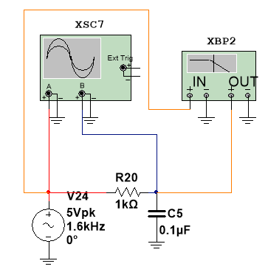 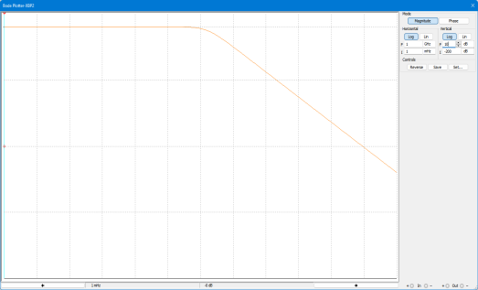

Fig-1: LPF Circuit

**CONCLUSION:**

From the above response we can conclude that the LPF circuit passes frequencies less than design frequency and attenuates frequencies greater than that.

1. **LPF with Direct Load Connection:**

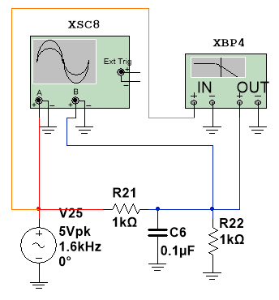 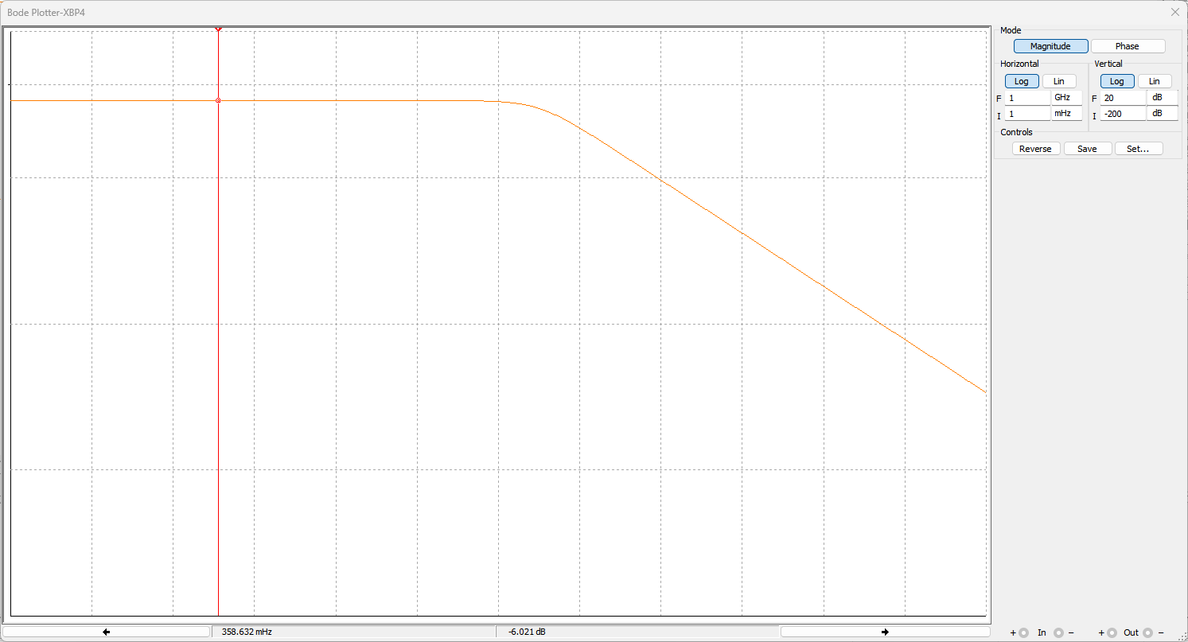

Fig-2: LPF Circuit with direct load connection.

**CONCLUSION:**

From the above response we can conclude that the LPF circuit passes frequencies less than design frequency and attenuates frequencies greater than that, and due to direct connection b/w capacitor and load resistor there is a burden on capacitor and the gain of the system decreases.

1. **Active first order LPF using OPAMP 741 with unity gain:**

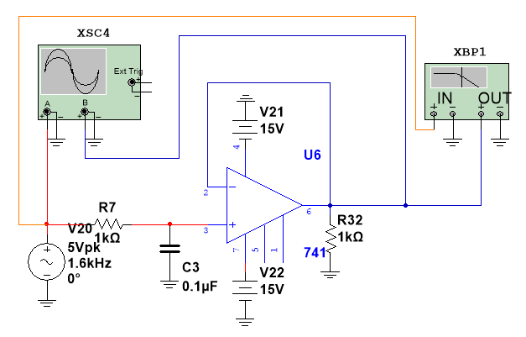 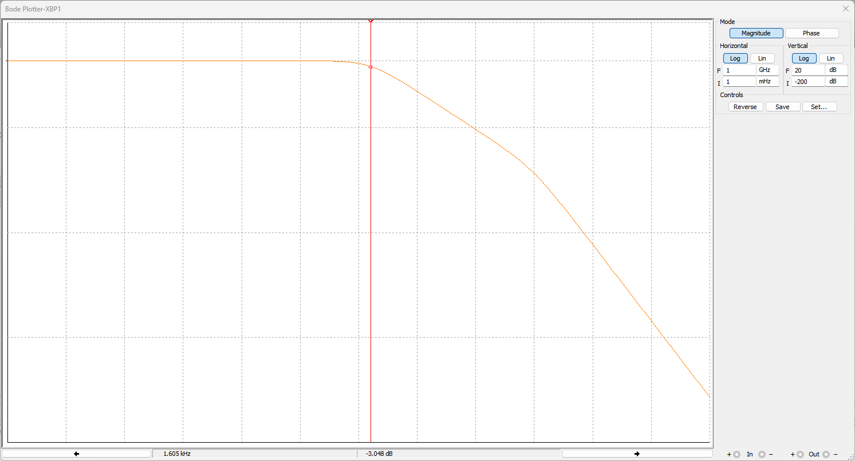

Fig-3: **Active first order LPF using OPAMP 741 with unity gain.**

**CONCLUSION:**

From the above response we can conclude that the LPF circuit passes frequencies less than design frequency and attenuates frequencies greater than that, and due to buffer circuit b/w capacitor and load resistor there is no burden on capacitor and the gain of the system is not disturbed as op-amp consumes zero input current.

1. **HPF:**

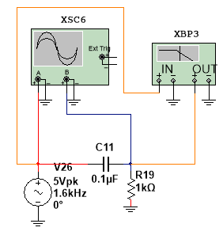 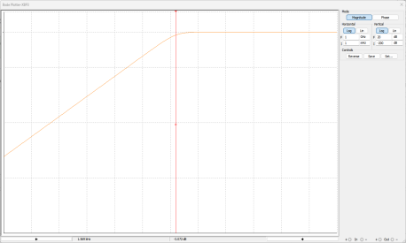

Fig-4: HPF Circuit

**CONCLUSION:**

From the above response we can conclude that the HPF circuit passes frequencies greater than design frequency and attenuates frequencies lesser than that.

1. **HPF with Direct Load Connection:**

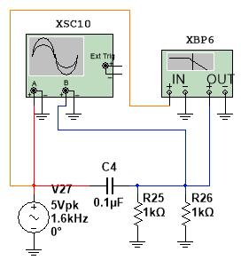 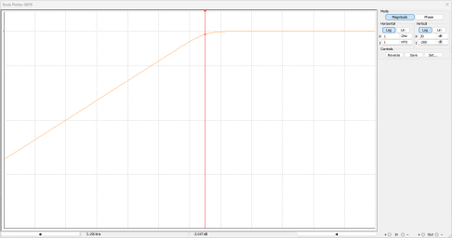

Fig-5: HPF Circuit with direct load connection.

**CONCLUSION:**

From the above response we can conclude that the HPF circuit passes frequencies greater than design frequency and attenuates frequencies lesser than that, and due to direct connection b/w the two resistors the frequency for which we have designed the circuit is being shifted.

1. **Active first order HPF using OPAMP 741 with unity gain:**

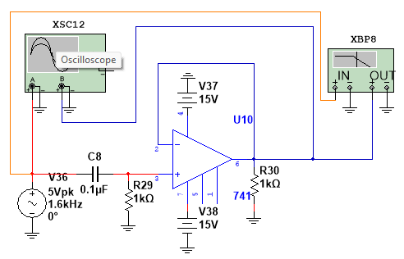 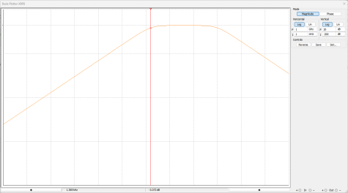

Fig-6: **Active first order HPF using OPAMP 741 with unity gain.**

**CONCLUSION:**

From the above response we can conclude that the HPF circuit passes frequencies greater than design frequency and attenuates frequencies lesser than that, and due to buffer circuit b/w two resistors the designed frequency is not affected.

1. **Result:**

We have designed and implemented active LPF and HPF using OP-AMP [LM741].

Signature of the Faculty